The world outside my window surrenders to darkness, the city lights twinkling like scattered diamonds. Inside, my domain glows with a different kind of light – the soft blue emanation of my computer screen. This is my time – the realm of the night-coding owls. The daytime bustle of emails, meetings, and interruptions fades away, replaced by a profound sense of focus. In the quiet solitude of the night, the lines of code flow more freely, problems untangle with a newfound clarity. It's a time for deep dives into complex algorithms, for chasing down elusive bugs that seem to multiply under the cloak of darkness.

There's a certain magic to coding at night. The world feels suspended, a canvas waiting for my creative strokes of code. The pressure to deliver during business hours evaporates, replaced by a self-imposed deadline fueled by endless cups of coffee and the thrill of the hunt. Each line typed, each hurdle overcome, feels like a small victory, a step closer to the digital masterpiece taking shape on my screen. The satisfaction of wrestling with a coding conundrum until the wee hours of the morning, then witnessing it work flawlessly at sunrise, is a unique reward reserved for those who embrace the night shift.

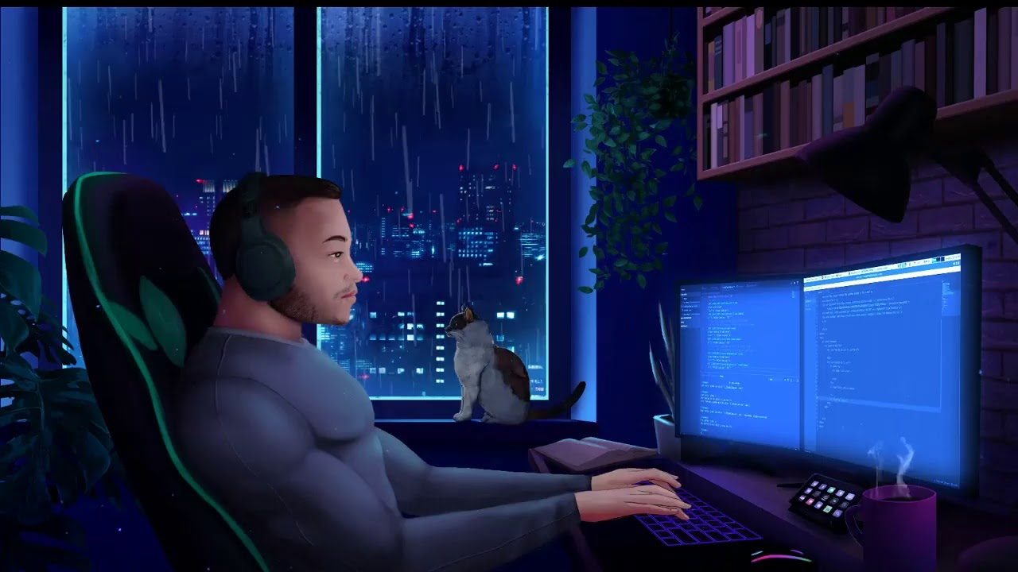

It's not for everyone, this nocturnal coding ritual. The temptation to hit the snooze button in the morning can be fierce. But for those wired differently, for those who find inspiration in the quiet hum of their computers and the boundless creativity of the night, coding after dark becomes a source of focus, a path to problem-solving, and a strangely beautiful way to chase the digital sunrise.